VOYAGE VISTA :ILLUMINATING INSIGHTS FROM UBER EXPENDITIONAY ANALYSIS

TEAM MEMBERS :

* SONIYA.V
* PAVITHRA.S
* ARULJOTHI.V
* MAHALAKSHMI.V
* MOHANASUNDHARI.S

1.INTRODUCTION:

In the dynamic world of modern transportation and technology, few companies have left as indelible a mark as Uber. The rise of this ride-sharing and transportation giant has not only disrupted traditional transportation systems but has also ushered in a new era of mobility and convenience. Uber's journey from a startup to a global tech powerhouse is a testament to its resilience and adaptability in the face of evolving markets, regulations, and customer preferences.

This project, "Expeditionary Analysis of Uber," aims to illuminate the insights gained from a comprehensive exploration of Uber's remarkable journey. By embarking on this analytical expedition, we seek to understand the various factors that have contributed to Uber's success, the challenges it has encountered along the way, and the strategies it has employed to navigate the complex terrain of the transportation industry.

Our exploration will encompass a broad spectrum of aspects, ranging from Uber's market expansion and competitive positioning to its technological innovations, regulatory encounters, and corporate social responsibility initiatives. We will delve into its financial performance, partnerships, and its responses to disruptive events, such as the COVID-19 pandemic. Moreover, we will contemplate the societal and environmental impacts of Uber's operations, as well as its efforts to foster diversity and inclusion within its ecosystem.

This project's journey is not solely about Uber's past achievements; it's also about glimpsing into the future. We will speculate on Uber's potential directions and strategies, considering the ever-evolving landscape of transportation and technology.

1.1. OVERVIEW:

This project aims to conduct a comprehensive analysis of Uber, the global ride-sharing and transportation company, in order to gain valuable insights into its journey, strategies, and impact on the transportation industry and society.

1.2. PURPOSE:

* To gain valuable
* To examine key focus area
* To inspire future research
* To contribute to knowledge

EMPATHY MAP:

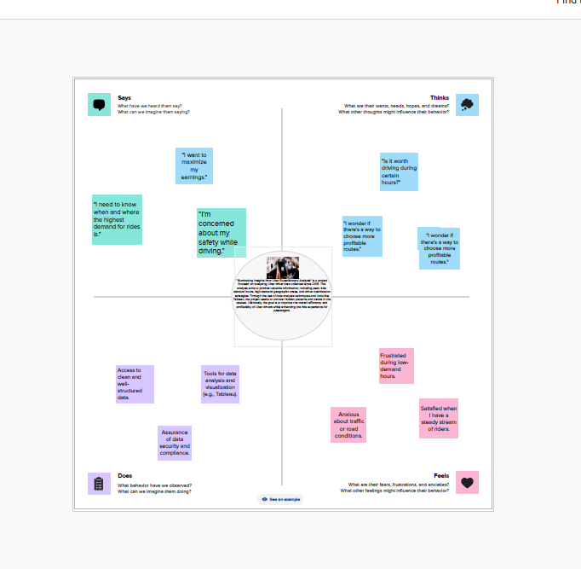

3.BRAINSTORM MAP:

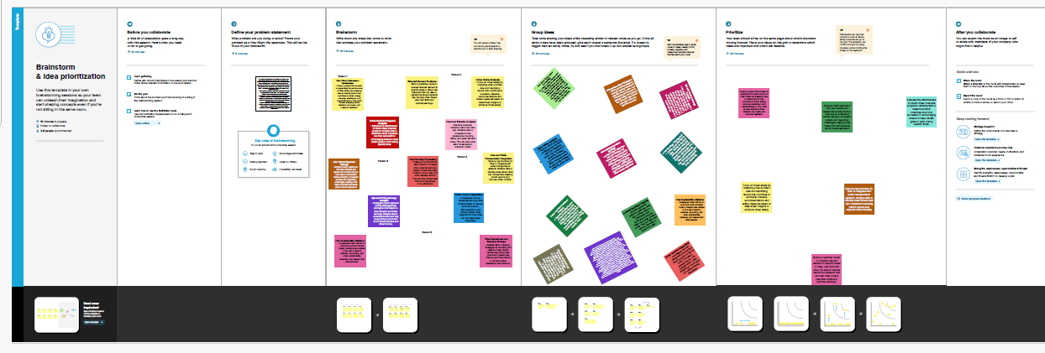

4.DASHBOARD:

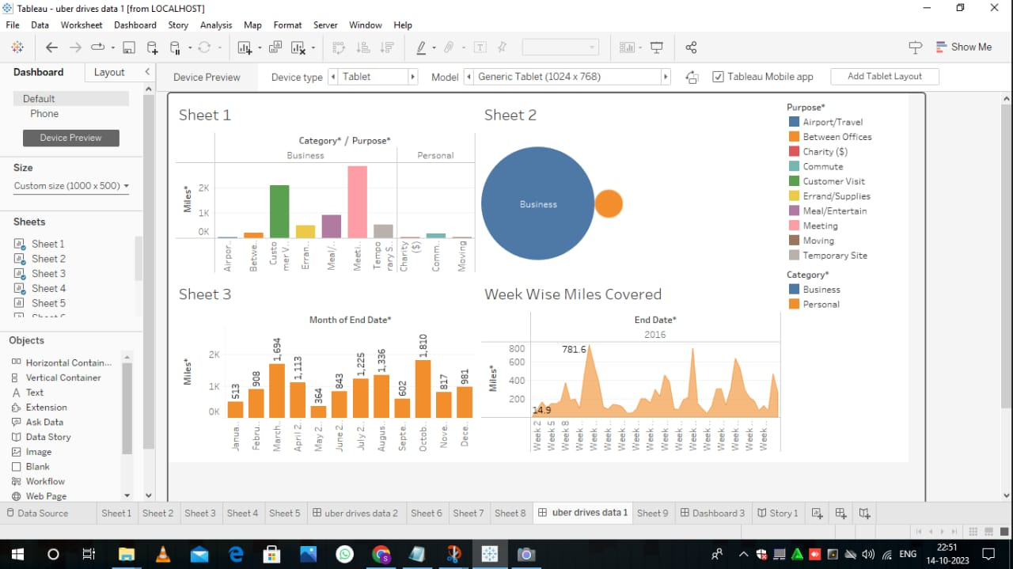

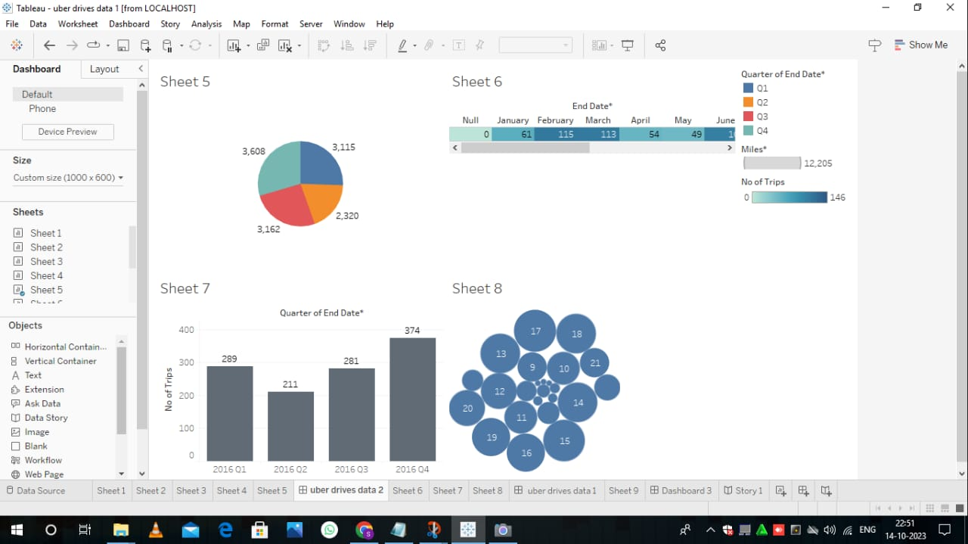

5.STORY LINE:

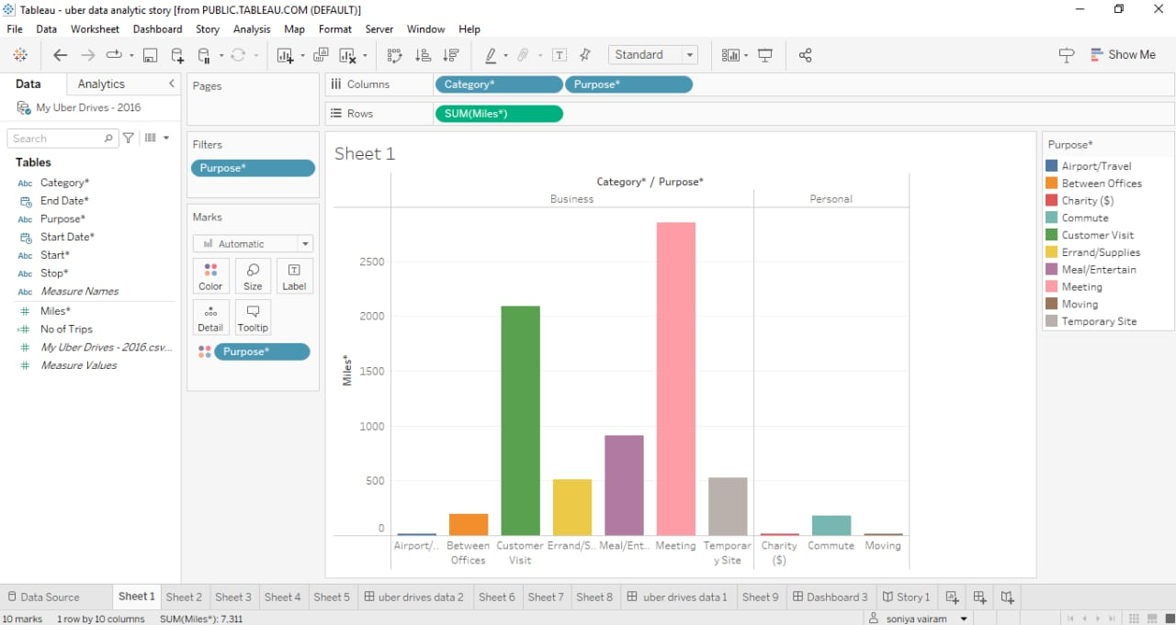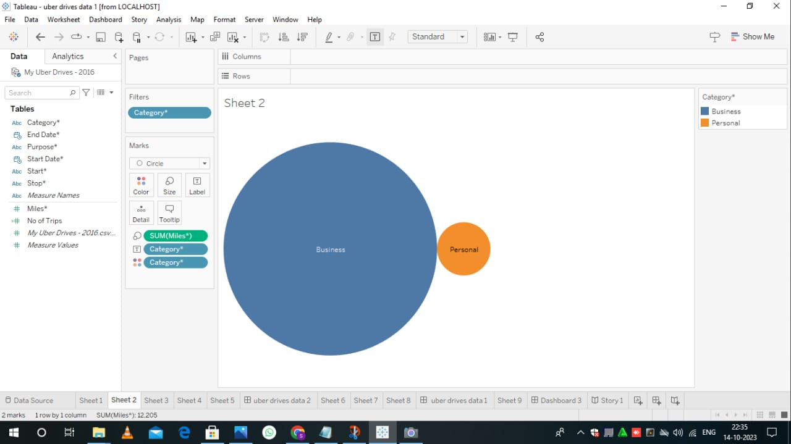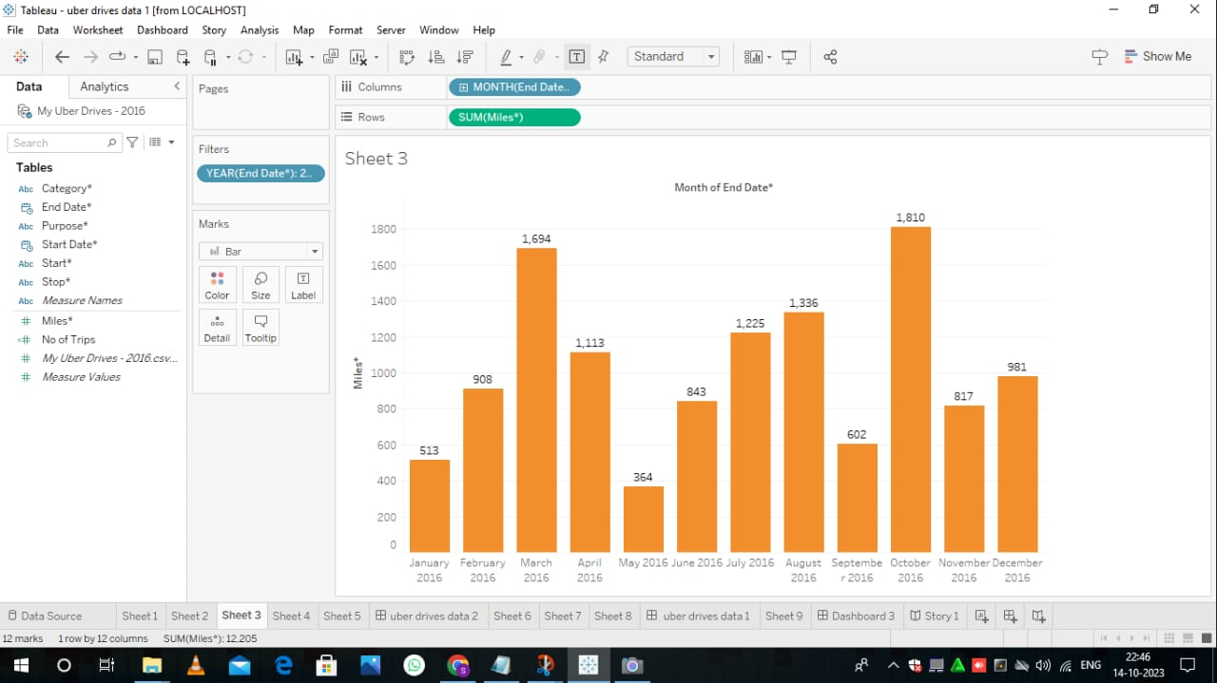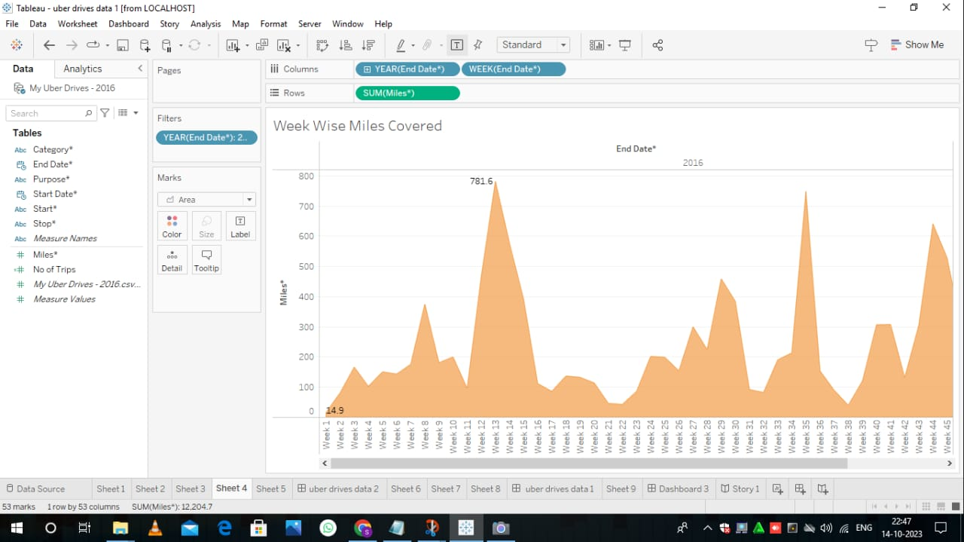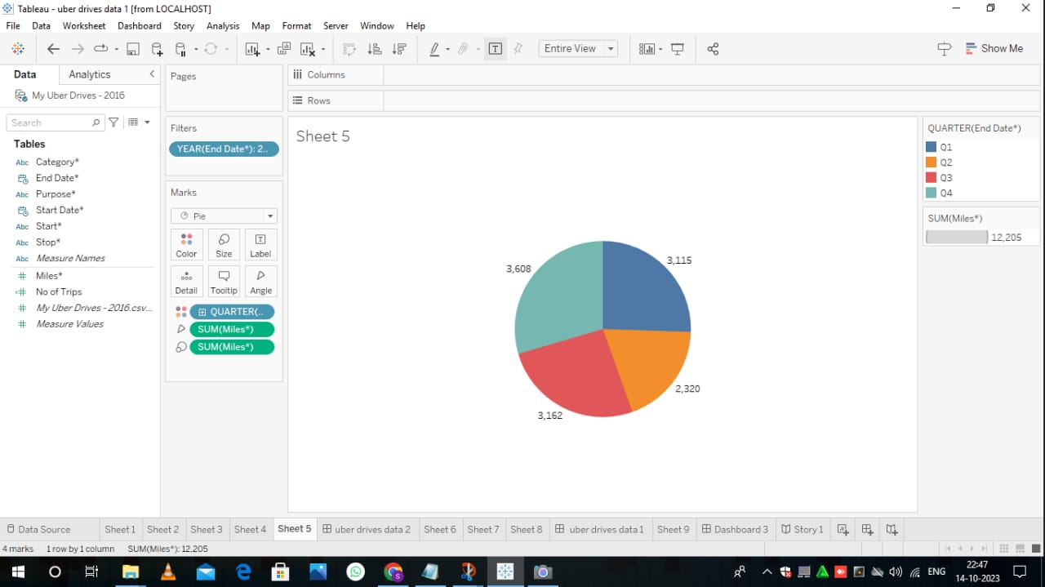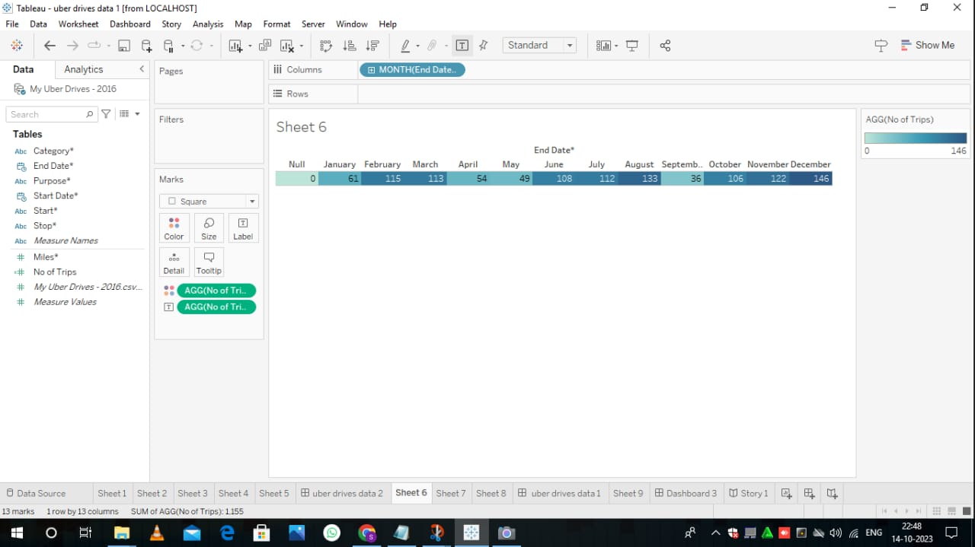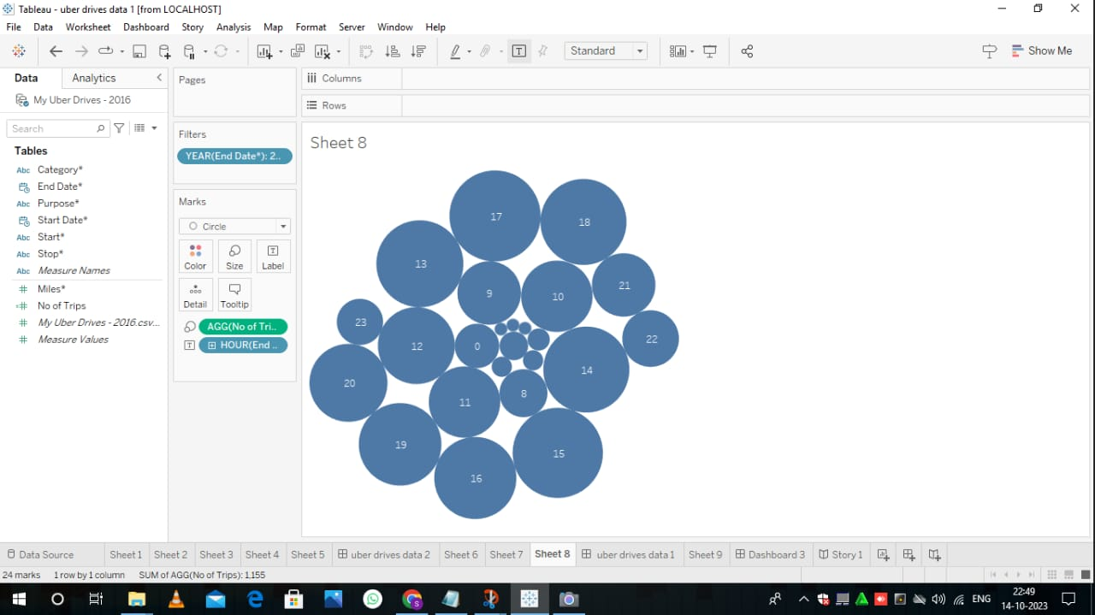

ADVANTAGES:

* Insight generation
* Informed decision making
* Improved understanding

DISADVANTAGES:

* Resource - intensive
* Data limitations
* Time sensitivity
* Cost

7.APPLICATIONS:

* Traffic management
* Public Transport
* Safety and Security

8.CONCLUSION:

In the light of these findings, we anticipate a myriad of opportunities for policymakers, businesses, and researchers to harness these insights and apply them to drive positive change. Urban planners can optimize transportation systems, businesses can enhance their customer experiences, and policymakers can create more effective regulations

AS we journey forward, let us leverage these illuminating insights to shape the future of transportation, technology, labor markets, and urban development

9.FUTURE SCOPE:

* International expansion
* Sustainability initiatives
* Education and Training